Use Case Realisation Report (Analysis) - Review Project Proposal
FOR
Volunteer Management System
(VMS)

CLIENT
PROJECT | Volunteer Management System (VMS)
TITLE | Use Case Realisation Report (Analysis) - Review Project Proposal
VERSION | 0.1a
DATE | 13-Aug-2011
 | ORIGINATOR
 | Name / Signature | Team 8S
 | APPROVAL
 | Name / Signature | Phung Kim Cuong, Dio
Institute of Systems Science |  | Document Reference
25 Heng Mui Keng Terrace  Singapore 119615 |  | VMS/T-1.4.1/13

 | Acceptance
 | Customer Signature |  | Customer Signature
 | Name & Designation |  | Name & Designation
 | Date & Company Stamp |  | Date & Company Stamp

Revision History

Date | Version | Description | Author
12-Jun-2011 | 0.1a | Creation | Team 8S
 |  | Refer to amendment history

Table of Contents

1. Brief Description 3
2. Flow of Events 3
2.1 Standard Flow 3
2.1.1 Review Project Proposal 3
2.2 Exceptions 4
3. Interaction Diagrams 5
3.1 Collaboration Diagram for Review Project Proposal 5
4. Participating Objects 5
4.1 Coordinator 5
4.2 HomeScreen 5
4.3 ProjectProposalListingScreen 5
4.4 ProposalDetailScreen 5
4.5 MainController 6
4.6 ProposalController 6
4.7 ProjectProposal 6
4.8 Staff 6
5. Class Diagrams 6
6. Derived Requirements 6
ANNEX D Amendment History 7

Use Case Realisation Report (Analysis) - Review Project Proposal

Brief Description
The use case enables a Project Coordinator to review the list of project proposal and decide whether to approve or reject the proposal.

Flow of Events
The standard flow of events for this use case and any exceptions are described in the following subsections. See section 3.1 for an overview of the participating Actors and Domain Objects.

Standard Flow
Precondition: User has logged in the system and the user role is project coordinator
The workflow is as below:

Review Project Proposal
- The use case starts when the Coordinator selects the Review Project Proposal menu option from the HomeScreen. The HomeScreen.getProjectProposalScreen() operation is triggered.
- The HomeScreen.getProjectProposalScreen() operation triggers the MainController. getProjectProposalScreen() which delegates to the loadProposalList() operation of the ProposalController.
- The ProposalController will then use the StaffController.getStaffDetails() operation to get an instance of the current logged in staff.
- Then it triggers the getStaff() operation of Staff entity to return an instance of current staff.
- Then the ProposalController will trigger ProjectProposal.getProjectProposal() using the instance of Staff object as parameter to return a list of all project proposal for this current user.
- Then the ProposalController will call the ProjectProposalListingScreen.show() to display the list of project proposal.
- The actor then select a record of proposal and trigger the getProposalDetails operation of the ProjectProposalListingScreen, which in turns delegate to ProposalController.getProposalDetail() operation.
- The ProjectProposalListingScreen.getProposalDetail() operation will call the ProposalController.getProposalDetail() to filter the project proposal list.
- After that, the ProposalController will call the ProposalDetailScreen.show() to display the project proposal record.
- Then the actor can perform the update (reject or approve) the proposal. This action will trigger ProposalDetailScreen.updateProposalDetail()
- Then the ProposalDetailScreen will call the ProposalController.updateProposalDetail() method, which delegate to the ProjectProposal.update() operation
- When the ProjectProposal.update() complete, the ProposalController will display a message via ProposalDetailScreen.showMessage() to inform the actor.
- The use case terminate when the actor click Close button on the ProposalDetailScreen, which trigger ProposalDetailScreen.close() method.

Exceptions
The following exceptions were identified:
- Update fails. If the ProjectProposal.update() operation fails, the project proposal is not updated. An error message will be displayed in the ProposalDetailScreen by the operation ProposalDetailScreen.showMessage().

Interaction Diagrams

Collaboration Diagram for Review Project Proposal
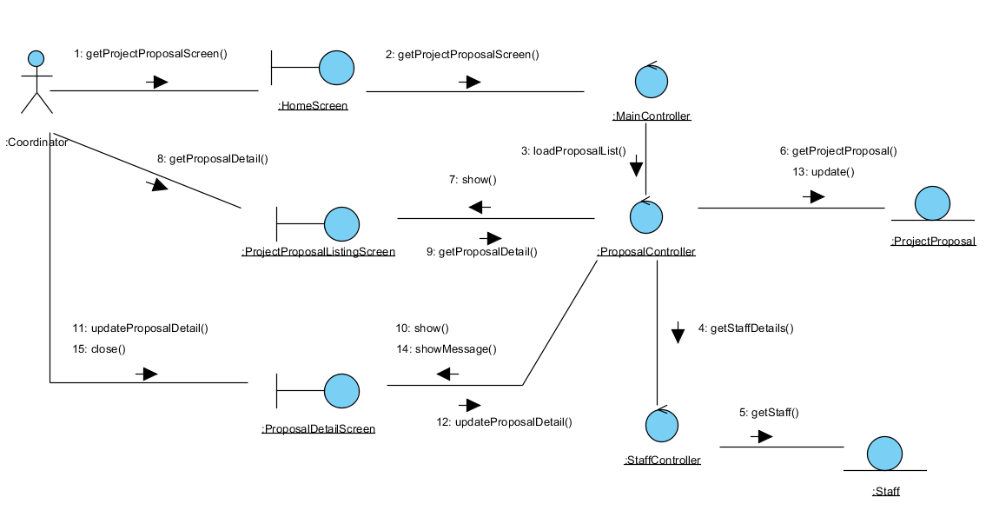
Figure 1 – Review Project Proposal

Participating Objects

Coordinator
This entity object represent the user with a role of Project Coordinator.

HomeScreen
This boundary object represent the home page of VMS.

ProjectProposalListingScreen
This boundary object is used for collection of project proposal listing. User actor uses this object to select and view a project proposal.

ProposalDetailScreen
This boundary object is used for displaying project proposal details. The Coordinator actor interact with this object.

MainController
This control object co-ordinates the menu selection and dispatches of requests of the volunteer management system. It delegates the user requests to the specific use case control objects for carrying out the use cases.

ProposalController
This control object co-ordinates the update, viewing and searching project proposal record in the system. It receives requests from the boundary objects allocated for the specific purposes, along with all the necessary details required for the execution of these requests.

ProjectProposal
This entity object represent a record of project proposal in the system. It stores all details regarding project proposal.

Staff
This entity object represent a record of staff in the system. It stores all details regarding staff information.

Class Diagrams

Derived Requirements
The Staff office PC (client system), keyboard and mouse will be used to process the project details and view all the system responses.

ANNEX D Amendment History

This is a record of all amendments made to the Document.
Version | Chapter / Section | Page No | Notes of Amendments or Changes

